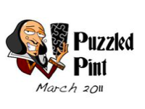
Too Much of a Good Thing!

Amaze | Moonious
Multitud | Loess
Sancti | Table
Dish | Aption
Invulner | Hial
Premed | Pinous
Base | Earsten
Accommod | Meant
Impart | Merege
Sub | Itrated

